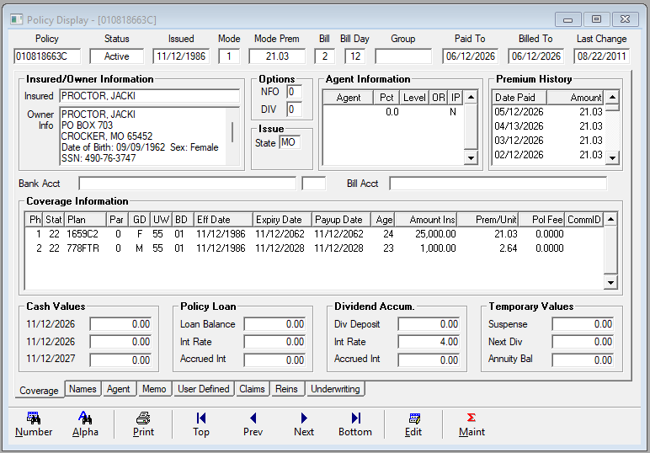
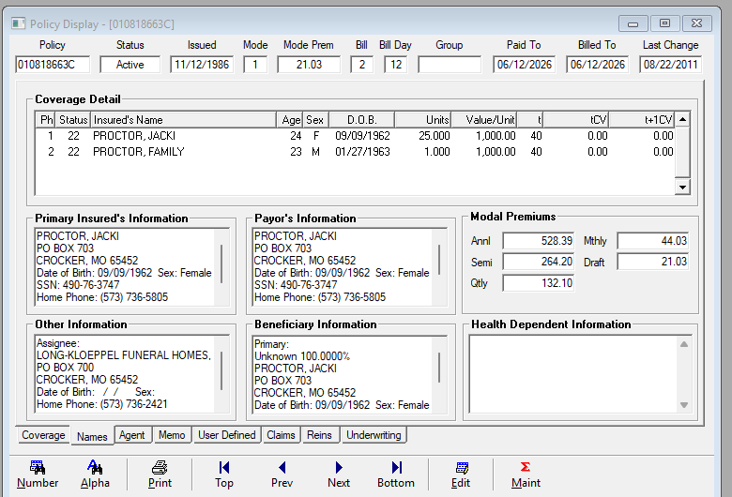

Issues:
- Last Change Date – 8/22/2011 vs 9/21/2011 – highlighted in yellow
  - The 9/21/2011 change date is listed in PPOLC_PolicyMaster_Extract_20260530 in Column K (LAST_CHNGE_DATE)
- Premium History stops at 1/12/2018, while LifePRO accounting history goes back to 6/30/2001
  - LifePRO has Post-Tefra Basis and Premiums Paid-to-Date
    - Column BH (FV_Basis2) in PPBEN_PolicyBenefit_Extract_20260530 lists Basis
    - Question of how does QLAdmin capture the Total Premium paid and Cost Basis?
- Primary Beneficiary in QLAdmin states Unknown and Lists correct information.
  - What is needed to resolve the Unknown classification?
- Policy Fee is not listed in QLAdmin but is $25 in LifePRO
  - PPOLC_PolicyMaster_Extract_20260530 lists POLICY_FEE in Column BE
- Underwriting Class is S on PPBEN_PolicyBenefit_Extract
- NFO is APL ETI in LifePRO but listed as 0 in QLAdmin
  - PPBENTYP_BenefitType_Extract_20260530 Column DB (BF_NON_FORFEITURE) has value
    - Type_Code must be BF, which include 658 CEN I, 658 CEN SD, 659 CEN II, 659 CEN SD, 659 CEN SR, 659 SR GD, 668 SPWL, 669 SR GD, 679 CEN SD plans
- Interest Rate is incorrect (4% vs 4.50%) – Highlighted in Yellow
- Cash Values are missing – Highlighted in Yellow
  - Column BL (FV_BALANCE2) in PPBEN_PolicyBenefit_Extract_20260530 lists Cash Value
    - Tied to FV Benefit Type
- Routing Number and Bank Account are Missing
  - Bank Account is listed on PPPAC_PACDetail_Extract_20260530 in Column H (E_ACCOUNT_NUMBER)
  - All ELEC_ABA_NUMBER (Column BT) on RelationshipNameAddress_Extract_20260530 are limited to 8 characters
    - It appears all are missing the last digit including this policy
      - See LifePRO Enter PAC Screenshot (Circled in Red)
    - There appear to be 872 unique Bank Name_IDs

